Standards and Quality Report
2021/22
The Meadows Private Day Nursery Ltd
Where Young Minds Grow

Introduction
The Meadows Private Day Nursery was opened in February 2017. It is a small open plan setting providing care for a maximum of 37 children aged 0-12 years of age at any one time.
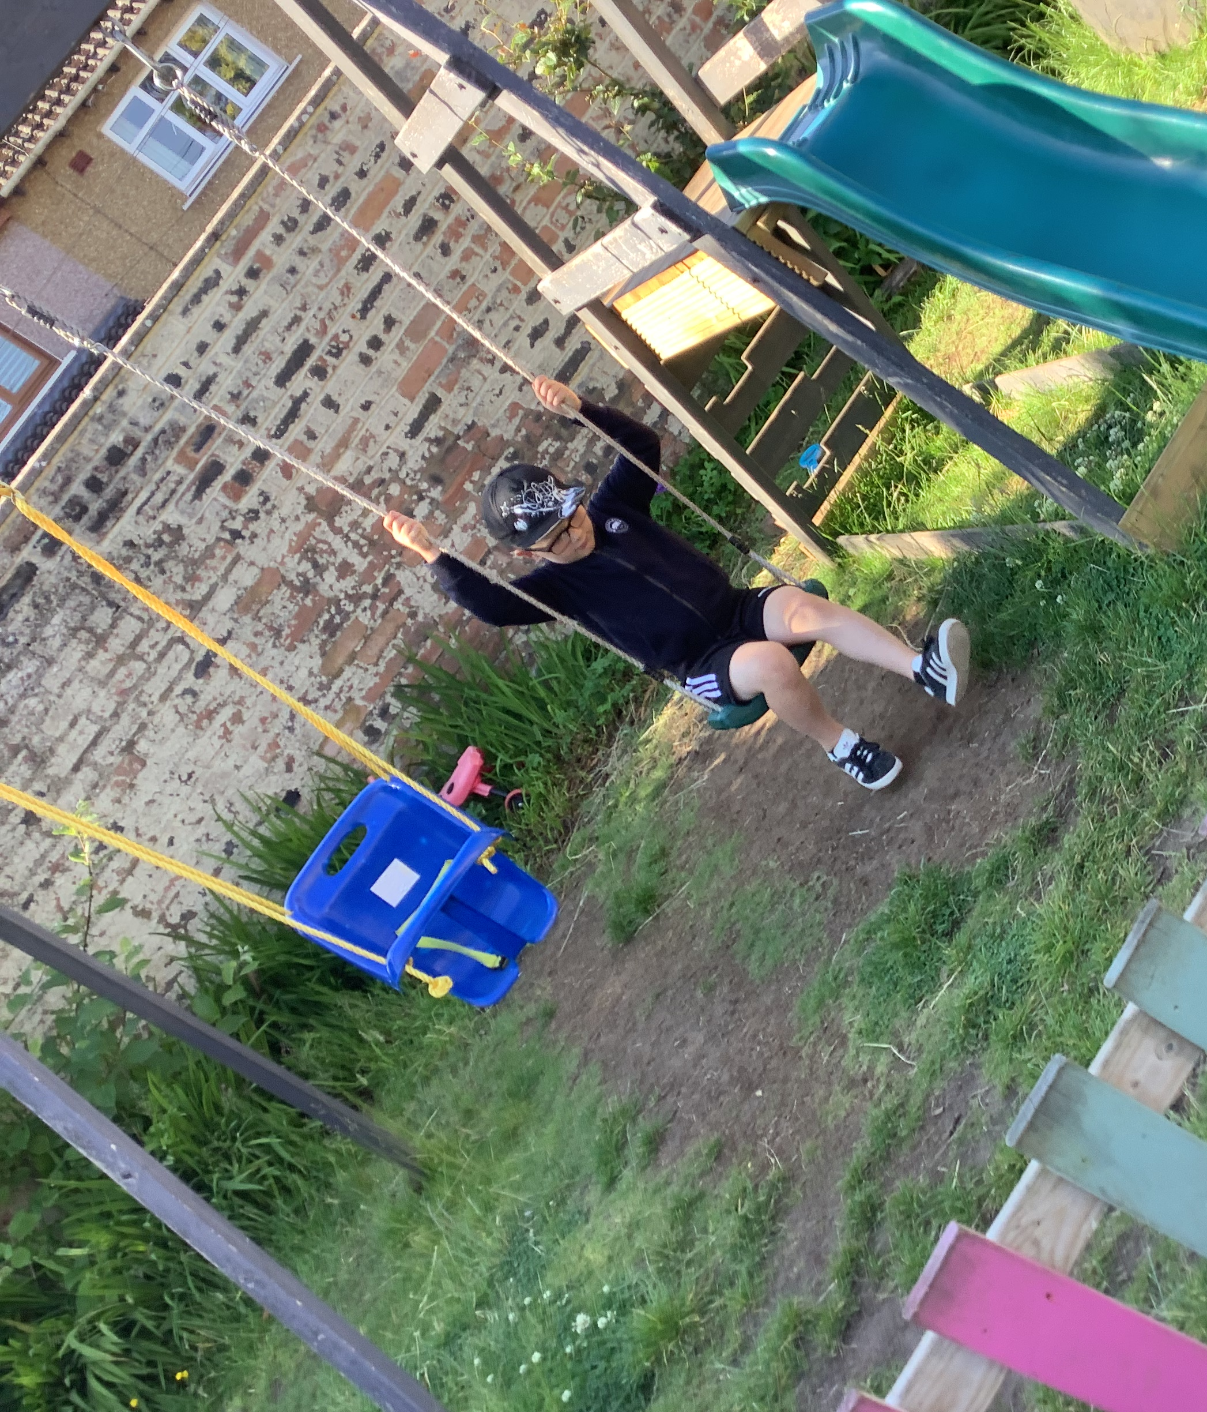
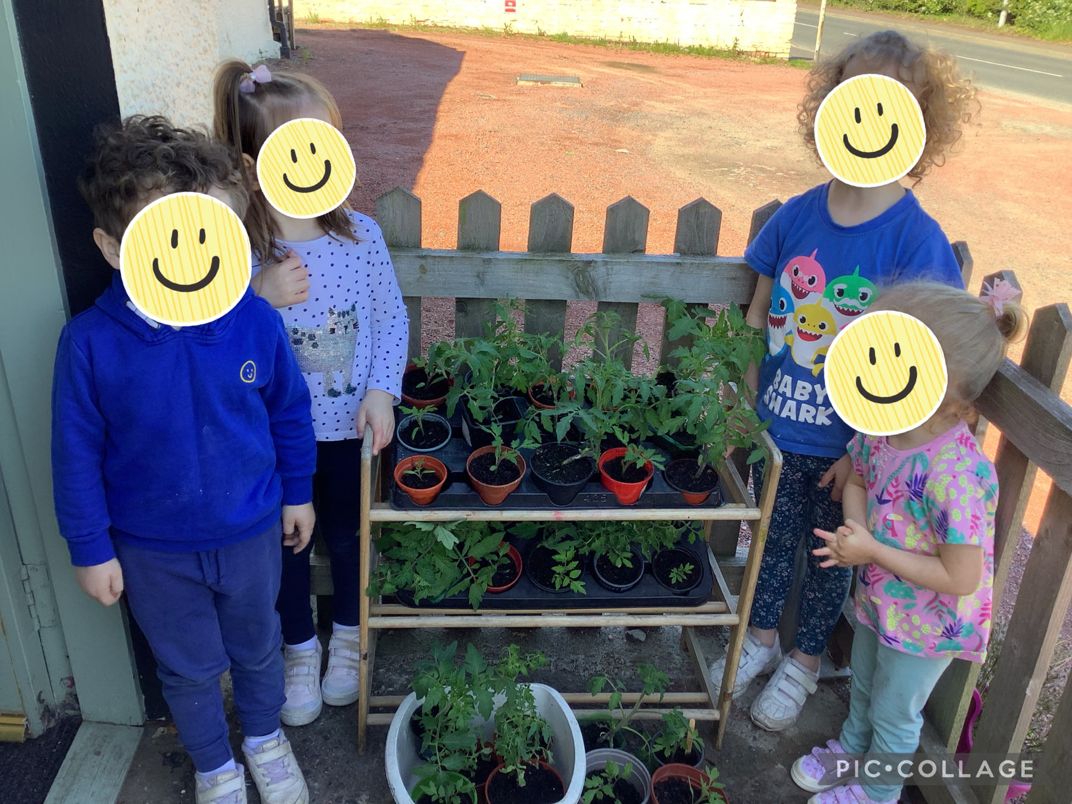
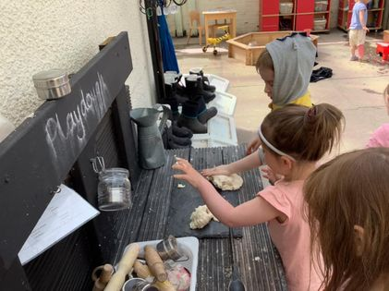
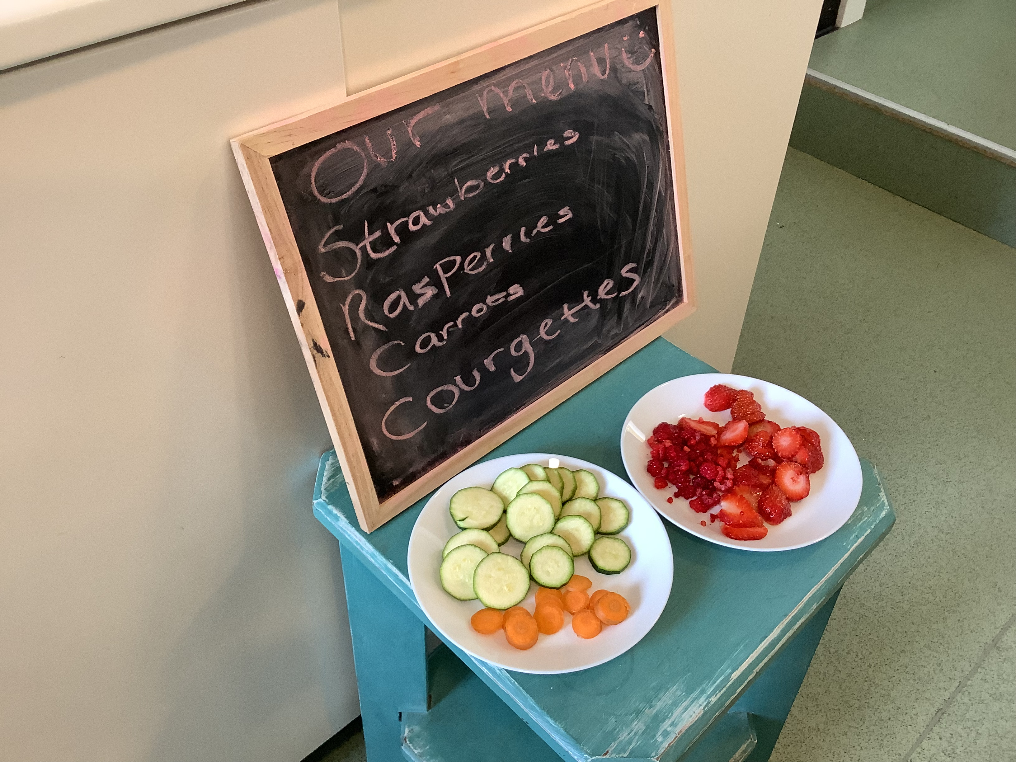
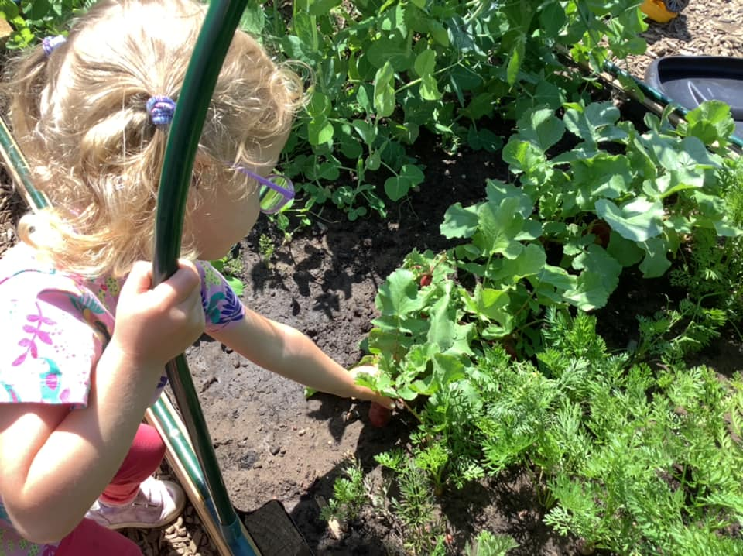
Vision
Giving away our tomato seedlings, Spring 2021
Fresh from our garden, Summer 2021
Tending our new raised beds, Spring 2021
New additions to our garden, Spring 2021

Our vision is to grow healthy and happy children by providing a safe and stimulating environment for children aged 0-12 years encompassing a wide range of age-appropriate activities and experiences within our indoor and outdoor areas. We foster positive relationships with children through nurturing, responsive care as well as with parents and carers, recognising the importance of strong partnerships between home and nursery. We aim to provide opportunities to improve outcomes for all children through promoting the rights of all our children in a respectful manner, ensuring they reach their full potential as Successful Learners, Confident Individuals, Effective Contributors and Responsible Citizens. As we are a small service, we aim to do this by creating and warm, welcoming home form home environment.

Values
- Dignity and respect
- Compassion
- Inclusion
- Responsive care and support
- Health and well being

Aims
To achieve our vision, we will work in close partnership with the children and their families to ensure that we meet their needs effectively through regular consultation and review. At present this is mainly done remotely via our online system Famly but we can also make appointments for phone consults and in person meetings where appropriate. We offer parents flexibility with regards to meeting their childcare needs through a booking system and the children’s needs are monitored and reviewed using the relevant curriculum framework documents Pre Birth to 3 and the Curriculum for Excellence as well as Realising the Ambition, Building the Ambition, Getting it Right For Every Child (GIRFEC) and How Good is our Early Learning and Childcare (HGIOELC).

Context of the early years centre
The Meadows Private Day Nursery is registered with the Care Inspectorate for a total of 37 children at any one time. This includes 6 spaces for children under 2 years old as well as 6 spaces for school aged children. Since opening in 2017 we have supported more than 200 children. From our last unannounced inspection in May 2018, we were graded –
Quality of care and support 4 - Good
Quality of environment 4 - Good
Quality of staffing 4 - Good
Quality of management and leadership 4 - Good

The nursery is located on the main B743 road which runs through the village of Mossblown. We provide care for families from the neighbouring villages of Tarbolton, Annbank, Mauchline and Ochiltree as well as the town of Ayr. Mossblown is part of the Ayr North and former Coalfields communities’ locality (ANFCC).
For the most recent time periods available, Ayr North and Former Coalfield Communities had:
- 12% of Mothers exclusively breastfeeding at 6-8 week review.
- 26% of Mothers smoking during first antenatal booking appointment.
- 50% of Teenage Pregnancies in Under 20s
- a 98% uptake of 6 in 1 Immunisation for the eligible population.
- a 96% uptake of 24 months MMR Immunisation for the eligible population
- 68% of Primary 1 Children with no dental caries
- 75% of Primary 1 children with healthy weight
- 0% of people lived in the least deprived SIMD quintile, and 59% lived in the most deprived quintile.

Table 1: Percentage population living in the 2016 and 2020 SIMD Datazone Quintiles

Quintile | Percent of Pop (2016) | Percent of Pop (2020) | Difference
SIMD 1 | 58.3% | 58.7% | 0.4%
SIMD 2 | 27.3% | 23.4% | -4.0%
SIMD 3 | 14.3% | 17.9% | 3.6%
SIMD 4 | 0.0% | 0.0% | 0.0%
SIMD 5 | 0.0% | 0.0% | 0.0%

The nursery is situated between the local schools and early years centres in Mossblown and Tarbolton. We can provide wraparound care for children attending these schools. As such we have good professional relationships with them and plan appropriate transition activities and celebrations for example during June for P1 transitions. Unfortunately, due to the COVID-19 restrictions this has been limited this year.

As of August 2019, we offer funded childcare to all 3 and 4 years old as well as eligible 2 years old on a flexible basis to suit the needs of families. This year we have had 13 ante pre-school children and 7 preschool aged children take up this offer. From these 7 preschool children 57% achieved all their communication developmental milestones, 57% achieved all their numeracy milestones and 100% achieved all their health and well-being milestones for starting primary 1. In 2019 we also moved towards ‘In the Moment Planning’ which has seen us change how we observe and plan for the children’s needs. This is something we have built upon by accessing more staff training on the subject and further meeting the needs of our children. This year will see our first cohort successfully graduating to P1.

January 2020 saw us expanding our service to enable us to deliver care and learning to under two years in their own separate area which in turn enabled us to better meet the needs of all our children and close the attainment gap as per the National Improvement Framework. This also enabled us to reinstate our before and after school care service. As a result, we have successfully achieved 100% in health and wellbeing as we are a small service, and we are able to offer the children a nurturing home from home environment in close partnership with our families. This is aided as our staff turnover is low and we employ local people with local knowledge. This enables our families to relax and share more openly which in turn means we have a better understanding of the children’s wellbeing needs. Prior to taking up a funded preschool place we were able to safely offer all our children an outdoor visit which laid the foundation for settling into our setting. This year we have identified key workers who have been able to support their key children. Last summer we had covered areas built and this year we have greatly improved our outdoor growing area to enhance the children’s access to fresh air and sunlight daily.

Referrals from external agencies can also be accommodated via a request for assistance procedure to offer families much needed support and respite. Since opening we have supported approximately 11 children through this system.

March 2020 saw us face our biggest challenge to date. In response to the COVID-19 pandemic we have remained open to provide key worker childcare for approximately 20 families. To date we have been able to do this in a professional, caring manner with no major issues for the staff team or the children and families. During lockdown when a lot of our children and families were at home we kept in touch via social media; we posted polls and videos of staff reading the winning story book, we shared videos the staff had made, and we made Facetime calls to our children. Our peripatetic teacher shared links that we also shared with our families and encouraged them to share what they had been getting up to on social media too. Guidelines put in place has meant that we have had to change the way in which we work with the main change being we no longer allow parents into the building. This means that we have had to increase our use of technology and we now share a lot more pictures with our parents via Famly so that they can still get a sense of what happens in the setting as well as keep updated with next seps and progression. Famly can also be used for general day to day messages with parents which has enabled us to still build relationships.

The building has 3 rooms to enable the children to develop and learn in a safe age-appropriate area. The Nest for approximately ages 0-2½, The Hive for approximately 2½-5 years and our smaller room The Burrow that houses our before and after school care. The setting cares for children from 7.30am until 6pm and offers a drop off and pick up service from Annbank and Tarbolton Early Years Centres and Primary schools. January 2020 saw the nursery increase its capacity with the opening of the new Nest room. This room allows the children to be better able to access age-appropriate resources and learning. The new room also saw the nursery introduce 3 room seniors and a key worker system.

There is a quiet area off The Nest to allow those children who require a rest during the day to do so without being disturbed by the day’s hustle and bustle. To meet the differing toilet needs of the children there is a separate changing room and children’s toilet with all amenities at the children’s level to encourage independence and privacy. We have a large, secure outdoor area at the rear of the building that the children access daily. Each room has access to a covered area so that the garden and outdoor play can be enjoyed year-round. These covered areas are a new addition in July 2020 and as such are a work in progress as staff and children work out how best to utilise them. These areas as well as our growing area will be our main development focus for 2021-2022.

The New Year of 2021 saw us undergo our first major staff changes with 2 of our longest serving members of staff taking maternity leave to add to their own families. This has seen our staff team grow from11 to 16. All staff within the nursery are qualified to or are working towards their SCQF level 7 award in early years. Senior staff are also working towards their SCQF level 9 qualifications. From the total staff team, the manager is BA qualified, 1 senior is working towards her BA, 4 seniors or acting seniors are working towards their SVQ level 9, 1 practitioner is SVQ level 9 qualified, and 1 practitioner is working towards her SVQ level 7 with the rest being level 7 qualified. In August 2021 we will take on our first Modern Apprentice. All staff members have annual supervision and appraisals which helps to identify areas for improvement that they can access to help meet their SSSC PRTL requirements. In line with our partnership agreement with South Ayrshire council we have a peripatetic teacher supporting the children’s learning.

Staff meet the developmental needs of all the children through fun activities following In The Moment Planning. This sees them carrying out focused observation of the children and consultation with them to ensure everything is appropriately geared towards their needs and interests. Parents receive regular updates on their child’s progress through our online daily diary via an app called Famly as well as individual reviews carried out at no longer than 6 monthly intervals. An open-door policy is in operation to discuss anything at any time following an appointment being arranged to maintain social distance measures for COVID-19 restrictions.

What key outcomes have we achieved?

School Priority
To develop and implement Literacy strategies that will impact on children’s overall attainment in this area with 75% of children reaching their pre-school developmental milestones.
Looking at:
- Breadth
- Challenge
- Application
To improve rhyme and verbal communication.
NIF Priority:-  - Improvement in attainment, particularly in literacy and numeracy  - Closing the attainment gap between the most and least disadvantaged children  - Improvement in employability skills and sustained positive school leaver destinations for all young people | Links to HGIOELC QI:-  2.3, 3.2
Progress and Impact
57% achieved their developmental milestones before starting school in August 2021
Next Steps
To develop and implement Literacy strategies that will impact on children’s overall attainment in this area with 75% of children reaching their pre-school developmental milestones.
Looking at:
  - Breadth
  - Challenge
  - Application
To improve rhyme and awareness of syllables.

School Priority
To develop and implement Numeracy strategies that will impact on children’s overall attainment in this area with 75% of children reaching their pre-school developmental milestones.
Looking at:
- Breadth
- Challenge
- Application
Pattern, measurements, and mathematical language in everyday context.
NIF Priority:-  - Improvement in attainment, particularly in literacy and numeracy  - Closing the attainment gap between the most and least disadvantaged children  - Improvement in employability skills and sustained positive school leaver destinations for all young people | Links to HGIOELC QI:-  2.3, 3.2
Progress and Impact
57% achieved their developmental milestones before starting school in August 2021
Next Steps
To develop and implement Numeracy strategies that will impact on children’s overall attainment in this area with 75% of children reaching their pre-school developmental milestones.
Looking at:
  - Breadth
  - Challenge
  - Application
Pattern, 2D shapes, 3D shapes, and mathematical language in everyday context.

School Priority
To develop and implement Health and Wellbeing strategies that will impact on children’s overall attainment in this area.
Looking at:
- Breadth
- Challenge
- Application
Support and counteract the impact of COVID-19 on children and families.
NIF Priority:-  - Closing the attainment gap between the most and least disadvantaged children  - Improvement in children and young people's health and wellbeing  - Improvement in employability skills and sustained positive school leaver destinations for all young people | Links to HGIOELC QI:-  2.3, 3.1, 3.2
Progress and Impact
100% achieved their developmental milestones before starting school in August 2021
Next Steps
To develop and implement Health and Wellbeing strategies that will impact on children’s overall attainment in this area.
Looking at:
- Breadth
- Challenge
- Application
Support and encouraged the children’s knowledge and understanding of where food comes from and what constitutes a healthy lifestyle.

Evaluation Summary

Quality Indicator | School Self Evaluation  (Please add 3 or 4 evaluative statements linked to the themes)
1.3  Leadership of change  Developing a shared vision, values and aims relevant to the school and its community.  Strategic planning for continuous improvement.  Implementing improvement and change | When policies and procedures are reviewed, they are shared on our closed group parents Facebook page for review and comment by all.  Staff members reflect on the overall practice of the setting using the challenge questions from HGIOELC during monthly meetings.  When policies and procedures are reviewed, they are shared on our closed group parents Facebook page for review and comment by all.
2.3  Learning, Teaching and Assessment  Learning and engagement  Quality of interactions  Effective use of assessment  Planning, tracking and monitoring | Focused child observations are carried out using a fortnightly rolling list.  Staff work consistently in the same rooms to build up relationships with children and families.  WALT walls have been introduced to enable all staff to be aware of next steps rather than just key workers.  Famly generates progress reports and learning journeys for each child.
3.1  Ensuring wellbeing, equity and inclusion  Wellbeing  Fulfilment of statutory duties  Inclusion and equality | Staff members are building up positive relationships with those children and families who are accessing our service via a ‘request for assistance’. This encourages positive wellbeing outcomes for the wider family.  All staff members are registered with the SSSC and are aware of and working towards their PRTL requirements.  Staff members are knowledgeable of our children’s family backgrounds (whilst maintaining confidentiality).
3.2  Securing children’s progress  Progress in communication, early language, mathematics, health, and wellbeing  Children’s progress over time  Overall quality of children’s achievement  Ensuring equity for all children | Our playrooms have been named rather than them being referred to by the age of children in them. This lends itself to see individual needs and plan for them rather than ages.  Our new child focused observation and assessment paperwork lends itself better for parents to share achievements from out with the setting.  Achievements need to be recognised and celebrated more within the setting.  Staff members are building up positive relationships with those children and families who are accessing our service via a ‘request for assistance’. This encourages positive wellbeing outcomes for the wider family.

What are the key priorities for improvement in 2021/22
Priority 1: -
Raising attainment and achievement in Literacy, closing the poverty related attainment gap
To develop and implement Literacy strategies that will impact on children’s overall attainment in this area with 75% of children reaching their pre-school developmental milestones.
Looking at:
- Breadth
- Challenge
- Application
To improve rhyme and awareness of syllables.

Priority 2: -
Raising attainment and achievement in Numeracy, closing the poverty related attainment gap
To develop and implement Numeracy strategies that will impact on children’s overall attainment in this area with 75% of children reaching their pre-school developmental milestones.
Looking at:
- Breadth
- Challenge
- Application
Pattern, 2D shapes, 3D shapes, and mathematical language in everyday context.

Priority 3: -
Raising attainment and achievement in Health and Wellbeing, closing the poverty related attainment gap
To develop and implement Health and Wellbeing strategies that will impact on children’s overall attainment in this area.
Looking at:
- Breadth
- Challenge
- Application
Support and encouraged the children’s knowledge and understanding of where food comes from and what constitutes a healthy lifestyle.

What is the capacity for improvement?
As a growing setting we are constantly making improvements to our indoors and outdoors environments whilst maintaining a high standard of care and support. We are moving away from plastic limited resources to more natural and inviting ones. The Spring of 2021 saw us successfully apply and be granted a variation to increase our overall numbers slightly which will enable us more flexibility to meet the individual needs of our children. As such we have named our rooms The Nest, The Hive and The Burrow. This means we no longer look at our rooms as age categories and more needs based for the children using the rooms. Since opening we have maintained a stable management and staff team with a wealth of experience in various care and training backgrounds. We have had a few maternity posts being covered by our local HNC students from the previous academic year. The new year of 2022 will see us welcome back our staff from maternity leave which in turn will mean a slight staff restructure. As we have been open for a few years now we want to revise our values, aims,

and objectives in partnership with our families.

